CPA Hybrid


Make Thousands A Month From CPA The CPA Hybrid Method!

Thanks for picking up a copy of my latest CPA Cash Cow report. Promise me that you will read every word of this report and take action with it. With VERY LITTLE WORK on your part, you can have a system set up that can very easily bring you $100,000+ in the next year.
I don’t like to hype up my reports but this is 1 of those reports that I expect to get feedback on from people who start making LIFE CHANGING money! This isn’t something that you will have to invest 100’s of hours into to make money. It is very simple and even easier to outsource.
Let’s get right into it. To make a ton of money in this crazy IM world all you need is 2 things:
Targeted traffic + Great Offer = Tons of Cash
Now all we have to do is find this targeted traffic and give them what they want! How many times have you heard that? This method that I am about to show you is 1 of those “Sweet Spots” where everything comes together!
There are currently 16,000,000+ students enrolled in College in the U.S. alone. This includes Universities, Colleges, Trade Schools, Junior Colleges, etc. How do I know this? Because I have family in US and I often talk to them about everyday stuff.
If you can get in front of this huge group of people and offer them something that they are looking for then you are in for an enormous payday!
Plus we can leverage these same students to get in front of other college students for very cheap. Everyone knows that college students are always looking to make some money to party with. That means they are more than willing to do simple tasks to make some spending cash. The targeted audience will also become your source of outsourcing at very affordable rates. We will get into that later on.

Getting Started
First thing that we need to do is find some targeted offers to present to these college students. For that we are going to go the scholarship route. Every single student in the country would love to have more scholarships.
The average college student leaves college with STUDENT LOAN debts. These are burdens that will follow them around till they finally get them paid off.
So if we can get paid and paid well to have college students fill out offers for free scholarships we are onto a huge payday. Trust me because I am making a killing at this right this second.
When looking for any type of CPA offers, your first destination should always be http://offervault.com because you can search a ton of different sites all at once.
Let’s take a look and see what we can come up with:

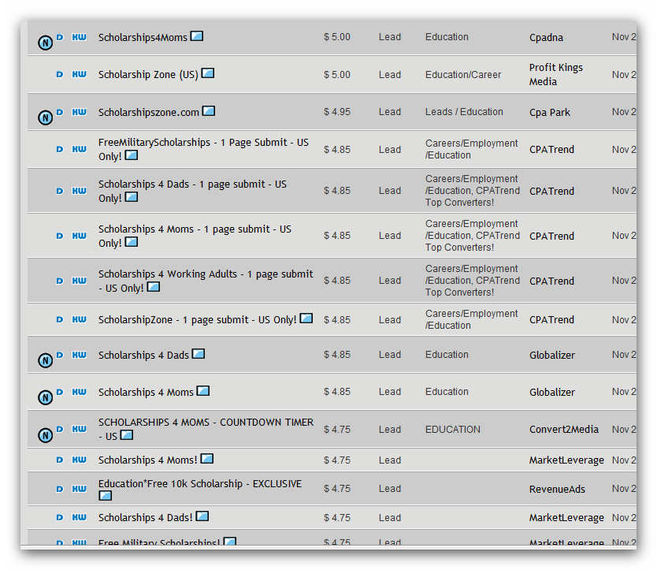

This is just a short screen shot of the available scholarship offers that are available for you to advertise. $5 for someone to fill out a short form is a good payday if you ask me. Do it on a mass scale it can mean life changing income!
Let’s take a look at 1 of these landing pages for the scholarship offers:

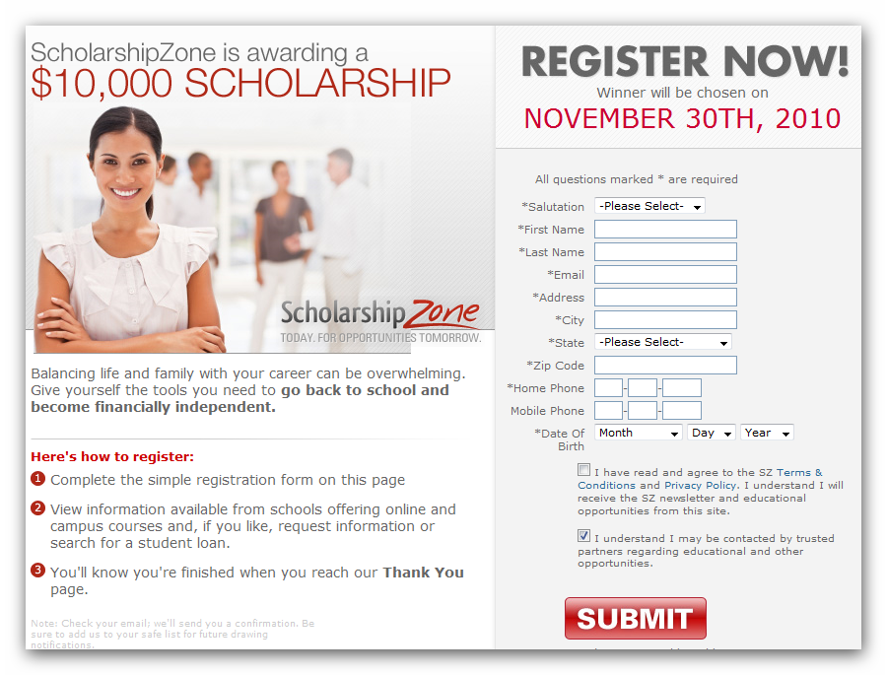

As you can see, it is a simple 1 page form that they need to fill out for you to get paid. College students are used to filling out forms exactly like this so the conversions are always very good.
Now we have established exactly what we are going to be offer, let’s get into how we are going to be getting traffic to these types of offers.
I want to go over the basic technique 1st.
I want you to have a clear idea of exactly what this method involves before we get into the advanced methods that will multiply your income like crazy.

We are going to be combining a few different methods of advertising into 1 “precision strike” advert.
I am sure that you have heard of putting up flyers on cork boards and different places that have “tabs” on the bottom that people can pull off with a website listed on them? These work but the problem is that the flyer has to catch someone’s attention while they are walking by.
Now a better way to advertise this type of flyer is get it in front of a “CAPTIVE” audience. What group is more captive then students who are stuck in a class room for long periods of time? Now that laptops are a common site to see in college classrooms, getting some targeted traffic is going to be real easy!
I will include an example of a flyer that you can use later on.
What we want to do is have the flyer put on the tables or desks of classrooms at a college or university. This way, when students come to class they will all see the flyer with your call to action on it.
The more customized you can make each one the better your conversions will be. Imagine this: You sit down at a desk for an hour long lecture 5 minutes early. You look down and see a flyer that says:
“We are giving away $10,000 Scholarships to students of [your school]! Visit url.com to get registered for FREE.”

Now, what do you think the average college student is going to do when they see that sitting on their desk and they have a few minutes to kill as well as a laptop sitting in front of them? At the very least, they are going to visit the URL to see what you are talking about.
A free $10,000 scholarship is a big draw to broke college students that have student loans piling up! You can rest assured that they will take the time to check out what you have to offer!
Check out this offer. This is a 1st page submit that pays out $24 for each person that fills out this 1 single page:
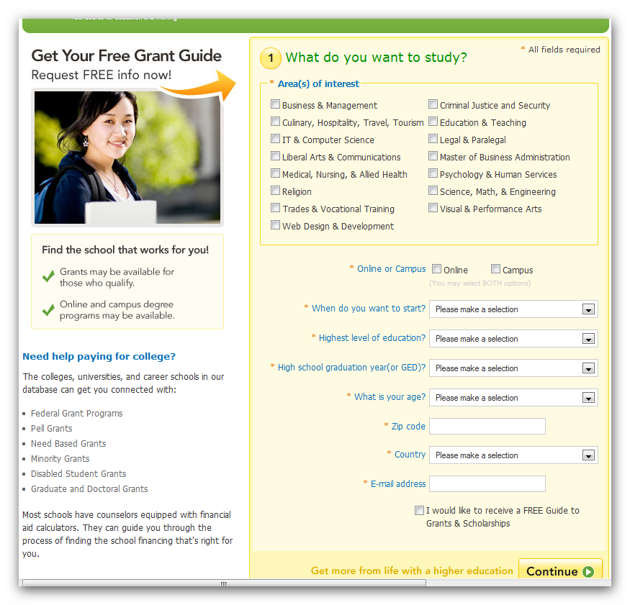

$24 for every single person that fills out that offer! I found it on http://monetizeit.net CPA network. I am in the process of testing this offer out to see how it compares to the $5 offer I showed in the beginning.
Just like anything else, this is a numbers game. The more desks that your flyer is on will determine just how much money you will make from this strategy.
To see exactly what type of flyer I am using, check out flyer.doc that I have included in this package. With this method, less is more. Tell them what they get when they visit your URL and tell them to actually visit it!
This is where most reports leave you hanging. They say “Go make a bunch of flyers and drop them off and you will make a lot of money!” They are right and you will make money. The difference between this report and some other reports that people are selling is that I am going to show you how to leverage this traffic and make 10x’s more money with some advanced tactics!
Ok, now that we have the basic idea down on paper it is time to get into the advanced strategies that will make this report blow away all the other reports out there that deal with making money from college students.

URL/TRACKING
Now, obviously you aren’t going to put a long and ugly affiliate link onto your flyer! That would make no sense at all.
The easiest way to do this is to buy a domain name and forward the traffic to the affiliate link. This is the least profitable method but also the easiest to set up so I want to walk you through this method first.
Let’s say that the domain name you buy is scholarcash.com. The most basic way to do this is to have this domain name forward to your affiliate link. That means that everyone who visits scholarcash.com will be immediately forwarded to the CPA offer that you are promoting.
The most basic form of tracking on this is to use custom urls to forward to the offer. I just grabbed a university from random: Auburn University.
To make custom urls for this method you would create a simple 1 page that forwards the visitor to the CPA page. Here is what it would look like:
www.scholarcash.com/auburn

Now all you would have to do is forward that page to the CPA offer so that they can fill it out. That will also allow you to track every single flyer that has that url on it to see how effective it is.
Taking this a step further, if you want to test different offers you can create several different pages that forward to different offers.
www.scholarcash.com/auburn1
www.scholarcash.com/auburn2
www.scholarcash.com/auburn3

Now, you could have each of these 3 different URLS redirect to different CPA offers and see which one makes you the most money. Don’t worry about conversion rates on the offers. What you want to see is how much money you actually make from 100 visitors to each offer. Whichever one makes you the most money should be the 1 that you use most often.
That is the most basic way to get 1 person to fill out 1 offer. This method is the easiest as well as the way that most people would attack this niche and method!
If you have learned anything from any of my reports, I like to go that extra mile and turn a few dollars into a ton of cash.
Instead of each person only having the option to fill out 1 single offer, why not give them the option to fill out several CPA offers?
I don’t know about you but I would rather get paid several times for each visitor! You have already done the work to get them to visit your url and that is the hardest part. Let’s tweak it just a little and see where it takes us.
So instead of just redirecting them to the offer, let’s send them to our own website with a custom page set up for each college that you leave flyers at.
So to multiply our options at getting conversions for each visitor, instead of www.scholarcash.com/auburn redirecting them to the website of the CPA offer, lets create a simple landing page that gives them the option of filling out of several options!
All you need is a simple landing page/wordpress page at that url that goes something like this:

-------------------------------------
“$10,000 scholarships are up for grabs for Auburn University students! These are absolutely free to sign up for and I don’t know how long we can keep these running!”
Offer #1
Offer #2
Offer #3

With that 1 simple change you are giving the visitor a more personalized experience while at the same time giving them more than 1 chance to fill out your offers!
Now we are getting somewhere with this method!

SOCIAL MEDIA:
Now we are getting college students to visit your site and fill out your offers. Depending on how aggressively you are dropping off flyers or outsourcing this money should be coming in at a very good rate.
Now why would we let these targeted visitors leave after just filling out 1 or 3 offers? Let’s create a list and a Facebook Fanpage with this targeted traffic!
The easiest way to build a list is to add an opt in box to the bottom of the page. So below the 3 offers all you would have to do is add a headline that says something like this:
“We will have many more Scholarship opportunities coming up, enter your name and email below to be the first to know about these great opportunities!”
A certain percentage of the visitors will opt in to your list. Knowing that the people who sign up are College students that are looking for scholarships is as targeted of a list as you can get.
Another option (and the 1 I like best) is to direct these visitors to a Facebook Fan Page! Think about it, a HUGE percentage of these people are already on Facebook. Not only that, they spend a huge amount of time on Facebook since that is where all their friends spend most of their online time!
All you have to do is create a Facebook fan page for your website and create a banner/link for them to “Like” your Fanpage!
As your Fanpage grows, the amount of money and different things that you can advertise on your Fan Page will only grow and grow. There is no need to chase them around because you can now just get them all in 1 location that they check often and spend a huge amount of time.
A fan page with LASER TARGETED college students will give you the ability to get some good terms on different marketing channels and turn that 1 time visitor into a long term revenue source!
Are you seeing how this simple method has the ability to create a LIFE CHANGING income when you approach it in a long term business manner?
OUTSOURCING:
Now let’s get into outsourcing this method so that you don’t have to spend all your time walking around college campuses. Doing it yourself is a great way to get started and get some cash to start outsourcing.
Who better to outsource this to then COLLEGE STUDENTS! Every college student is looking for ways to make money and they also already at the places you want to drop these flyers off at!
Now how you pay these college students is up to you. You can offer them $xx to put up 100-500 of these flyers. Depending on who you hire will determine the price you will pay.
The hardest part about this is tracking to see who exactly is actually putting them down. We can track all this using your CPA network and redirects.
Let’s say you find Sam who is willing to drop off 400 of these flyers. What you want to do is have the flyers created with a unique URL just for Sam.
www.scholarcash.com/auburn2 could be the url that you put on all flyers that Sam places. Inside of all CPA networks, you can add tracking and sub IDs. You can create as many of these that you want. So you would create a unique tracking code for each college student that you have placing flyers for you:

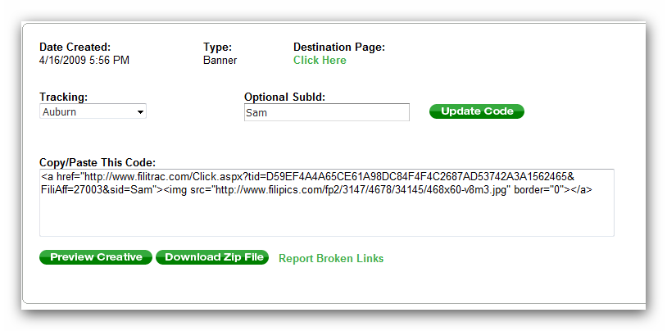

For Auburn I created a tracking campaign and named it Auburn. Any student that I had at Auburn who was going to drop off flyers for me I would add the Auburn tracking code. Then to specify each individual I would add their name to the Sub ID so I can track conversions down to each person.
www.scholarcash.com/auburn2
So if that was the url/page I created to track same, all the offers on that page would go through the Auburn tracking link with the Sub ID of Sam.
Each offer on that page (Offer #1, Offer #2, Offer #3) would all be clickable links that would take them to the offers through Sam’s unique SubID.
This simple tracking method will allow you to see who is actually placing the flyers and how well they are converting.
This leads us into a commission model for paying all of your outsources.
Forget everything about paying 50-75% of all your revenue like most people do for affiliate products. What I suggest you pay is 10-15% of all revenue generated by each person you have working for you.
To do this, you don’t want to actually telling these college students that you are only paying them that small of a %. Feel free to tell them that you are going to be paying them 50% but don’t actually show them the account. Create your own spreadsheet that shows them what kind of revenue they are creating but make sure that you downplay the numbers.
So let’s say that someone brought in $500 in revenue. Now, 15% of that would be $75 that you would pay the college student. So instead of showing them the $500 revenue, send them an email with a spread sheet showing that they brought in $150 and their 50% cut would be $75!
The more you pay the more they will work. So decide on a percentage that you are comfortable paying and keep to that no matter what percentage you tell them that you are paying them.
When they pass out more flyers and you make more revenue, make sure that you are paying them more! If they are doing more work and not making any more money because you are trying to be cheap then they will have no incentive to pass out more flyers!

Now let’s move onto finding college students to work for you. The easiest way to get started is to call up a college student that you know. I don’t care if it is a friend, cousin, neighbour, family friend, etc. Everyone can get in contact with 1 college student in their inner circle of people.
Find 1 person to get going on this, pay them CASH and I will guarantee that they will either scale up their flyer drop offs or they will recruit more college students to work for you.
The next is Craigslist. You want to place help wanted ads in the jobs section that college students will be most likely to look:
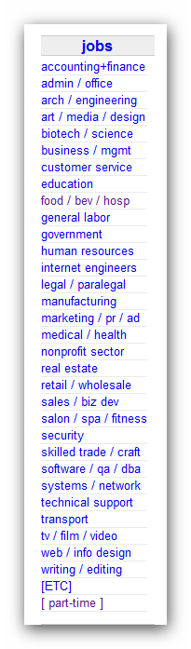

So Craigslist is a good place to find college students. The next best place to find college students is on Facebook. Every college kid in the country has a FB account.
http://www.facebook.com/#!/auburnu

Now there is a Facebook fan page just for Auburn. I know that not everyone who is a fan of that page will be a student there. What you want to do is look for current students. The best way to do that is to find out just who is currently commenting on the page:
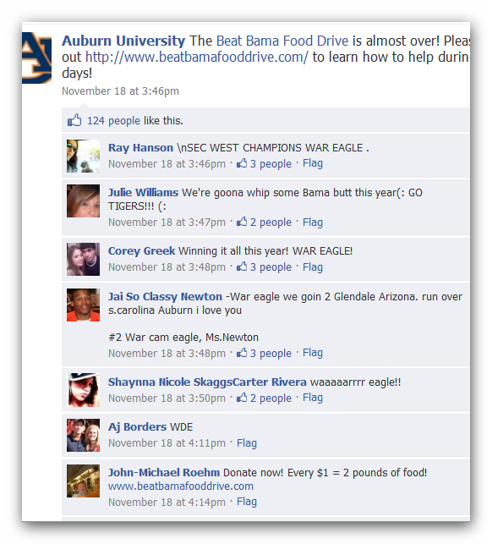

What are the odds that Ray, Julie or Corey is a current Auburn student? I would be willing to bet that they are. Now all you have to do is send them a friend request. Add a message and let them know what you are looking for:

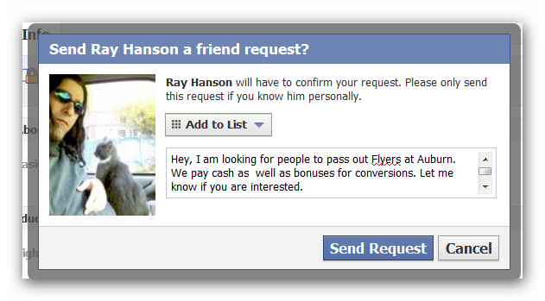

The worst they can do is not accept your friend request. If you want, (and I suggest you do) create a separate FB account just to contact people. That way you can make it look more professional when you are contacting college students.
There is no need to mix your personal account with business. The more credible you look the better your conversion rates will be when contacting college students to work for you.
ADVANCED TACTICS:
Now here are a few tips that you can use to get the most out of each flyer.
Instead of having these college students just drop off the flyers on the desks, why not have them place tape on the top of the flyers so that the students can’t take them with them that easily?

If someone takes the flyer with them then you can make a little cash.
If their flyer stays on the desk for the whole day or several days then the amount of people who will see it will increase dramatically and you will make more money per flyer.
Advanced outsourcing option:
Here is an option to expand your operation without having to deal with a ton of different college students. Instead of hiring 10 different people yourself, find 1 college student that wants to take care of all the flyer distribution for you!
So let’s say that you find 1 college student that is money hungry and has a good head on his shoulders. Instead of having him send all these new people to you, he can hire them himself!
The tracking would stay the same on your end. You will still want to create a SubID for each person that he hires. On the tracking code, you would just create 1 tracking code for the person that you are having expand your business.
This way you can pay just 1 person and they can take care of paying everyone else! You would send him a payment and spread sheets for everyone’s sub IDs that he has below him.
This method will cut down your time finding new college students as well as the hassle of having to deal with multiple people!
Here is where the rubber meets the road! This report has the potential to put $100,000+ into your bank account next year! This isn’t some pie in the sky number. It is on the low end of what you can make if you take this method and run with it.

There are 16,000,000+ college students in the U.S. that this method would apply to. If you want to talk about an evergreen niche, each year about 25% of them will move on and be replaced be a whole new group of potential prospects!
This method can be repeated and built upon for years and years to come! It can never become out-dated and no one can pull the plug on this! You don’t have to worry about Google changing their algorithm or your PPC costs shooting through the roof.
The amount of money you put in your pocket is completely up to you!

